**JUnit Basic Testing Exercise**

* **Exercise 1: Setting up JUnit**
* ***Scenario:***

You need to use different assertions in JUnit to validate your test results.

* **Step 1-**

Create a new Java project in your IDE (IntelliJ IDEA for Maven).

* **Step 2-**

Add JUnit dependency to your project; add the following to your pom.xml:

<dependency>

<groupId>junit</groupId>

<artifactId>junit</artifactId>

<version>4.13.2</version>

<scope>test</scope>

</dependency>

Now,

* + - Click “Load Maven Changes”.
    - JUnit and Hamcrest jars appeared under External Libraries.
* **Step 3-**

Create a new test class in your project.

Main class- Calculator.java

Path- src/main/java/org/example/Calculator.java

**Code:**

package org.example;

public class Calculator {

public int add(int a, int b) {

return a + b;

}

public int subtract(int a, int b) {

return a - b;

}

}

Test class- CalculatorTest.java

Path- src/test/java/org/example/CalculatorTest.java

**Code:**

package org.example;

import org.junit.Test;

import static org.junit.Assert.*;

public class CalculatorTest {

@Test

public void testAdd() {

Calculator calc = new Calculator();

int result = calc.add(2, 3);

assertEquals(5, result);

}

@Test

public void testSubtract() {

Calculator calc = new Calculator();

int result = calc.subtract(10, 4);

assertEquals(6, result);

}

}

* ***Outputs:***
* Step 1-

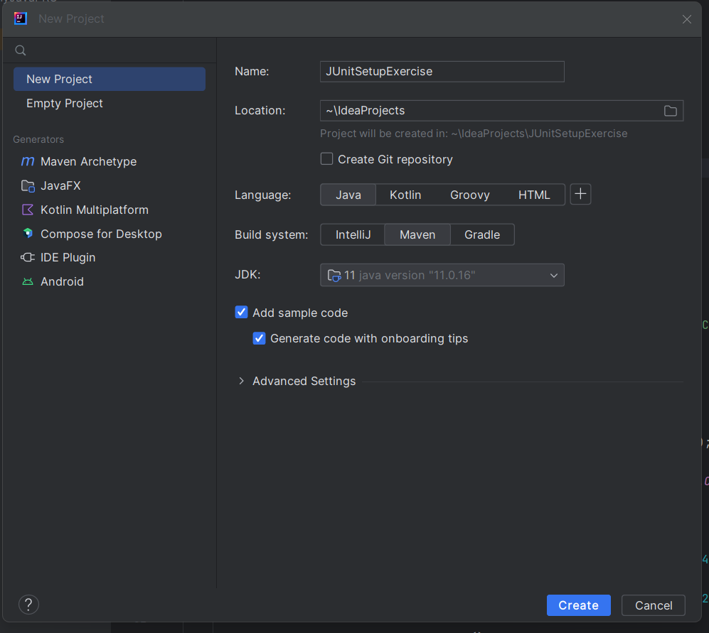

* Step 2-

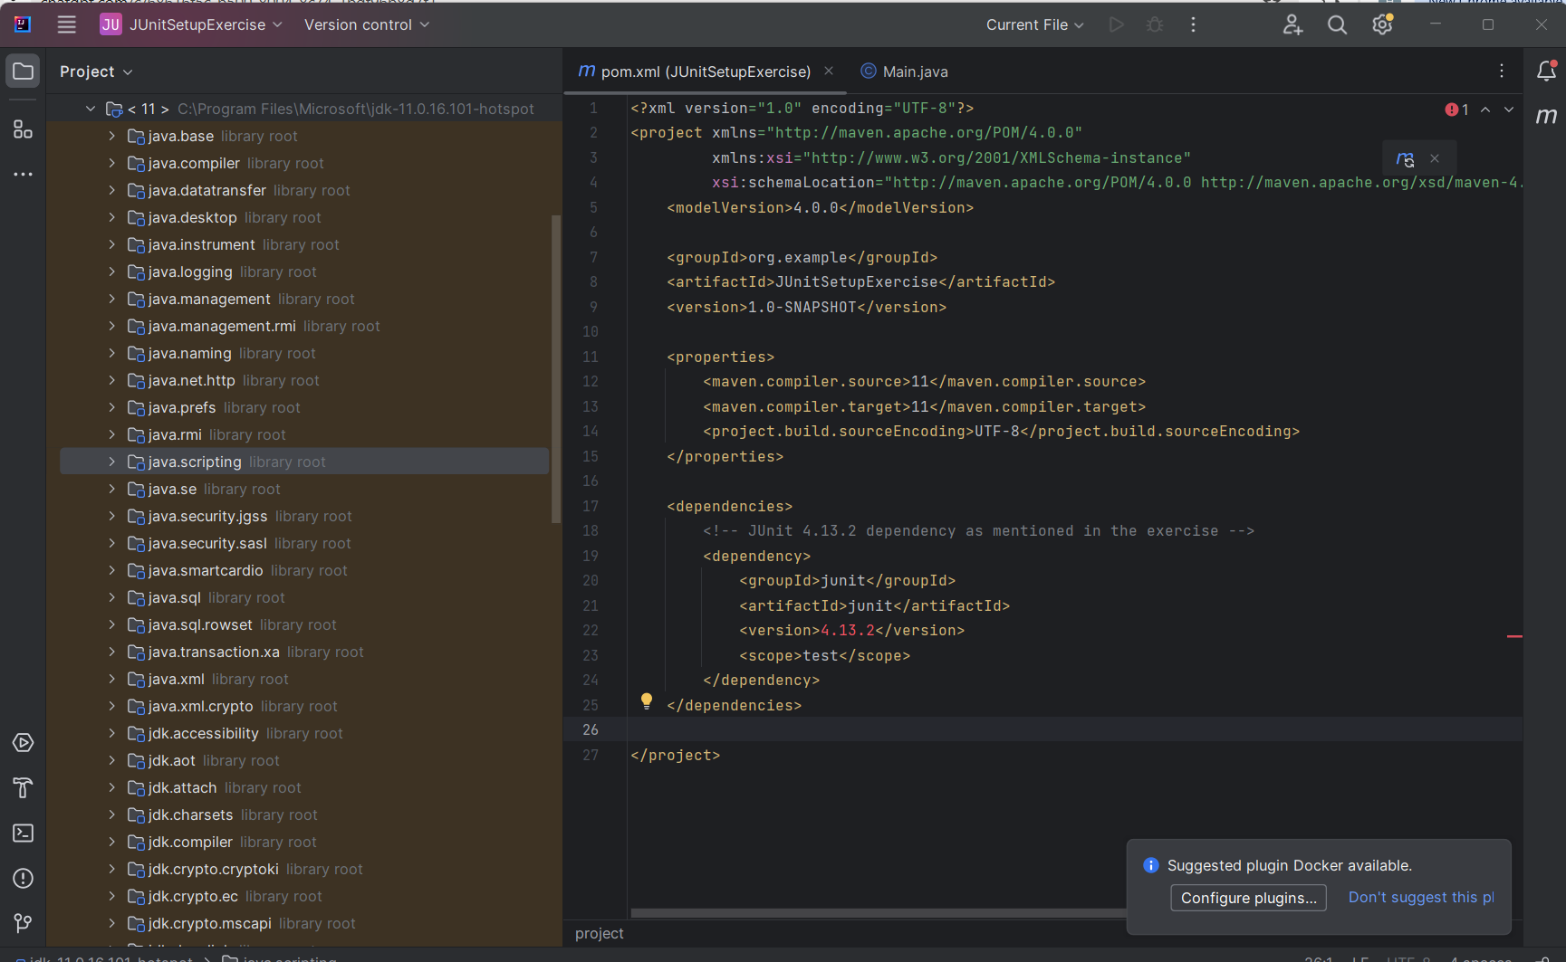

* Step 3-

